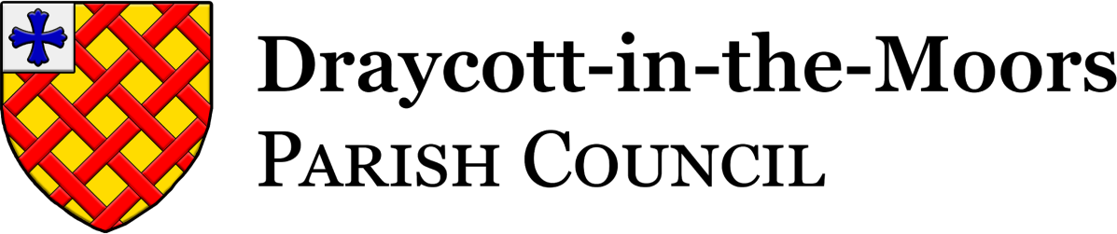

NOTICE OF AN ORDINARY MEETING - Monday 14th September 2026
A meeting of Draycott-in-the-Moors Parish Council
will be held at St Margaret’s Church Hall, Church Lane, Draycott, ST11 9AG - 7pm www.draycottinthemoorsparishcouncil.gov.uk
Signed: Parish Clerk, Yvonne Grimshaw Baker Date: 28/08/2026

AGENDA
- Chairman’s Welcome:
- Apologies:
- Declaration of Interests:

- Public Participation:
  - The Chairman will suspend Standing Orders to allow any members of the public to address the meeting.

- To approve the minutes of the Ordinary Meeting held on 13th July 2026 as a true and accurate record.

- Matters Arising from the minutes:
  - Update on the planters, Uttoxeter Road

DISTRICT & COUNTY COUNCILLOR REPORTS
- To receive oral reports from our District Councillors:
- To receive a report from County Councillor:

- Planning Applications:
Application Ref: | Address | Proposed Development
P/2026/00149 | SOUTH OF BOUNDARY LINE  BUSTOMLEY LANE  MORRILOW HEATH | Solar Farm

- New Items:
- Recognition of Young People's Achievements- To consider introducing a scheme to recognise and celebrate the achievements of young people within the parish, including the possible formation of a working group and an annual community awards event
- Cllr. Reardon has raised the problem of the new food waste bins not being collected, which is resulting in an increase in flies and maggots infestation. Problems have been reported to SMDC. The issue remains unresolved.
- Council to consider using an external contractor for Grass cutting. Cllr. Bentley to update further.

- Finance
  - To authorise payments for August
  - Council to consider the NALC pay award for the Clerks (see appendix10b)
  - Changing Banks to Unity Trust/NatWest progress report
  - Signatories to sign form to authorise direct debit for HMRC
  - Council to consider the updated application for Solar Array Fund; Parkers Piece information board.
- Items on Notice:
- Partial Review of Local Plan – Update on Public Meeting and Local Newspaper headlines.

- Projects in Progress:

HIGHWAYS
- Uttoxeter Road Crossing
PROJECTS
- Totmonslow signs: Quotes and update on application to the Moorlands Partnership Board
- Village Gateways. Updates and further news
- Bus Stop Art Galleries: Notice board project

COMMUNICATION
- Policies: In progress
- Calendar of Events 2026: Remembrance Sunday: to consider and agree arrangements, displays and any associated expenditure.
- Training and Development: To obtain authorization for Clerk to start training and join the SLCC

- Matters pertaining to issues in the Parish for the next Agenda:

- To note items raised in public participation to be discussed at the next Council meeting.
- Date of next Meeting: Monday 12th OCTOBER 2026
correspondence, written submissions to clerk@draycottinthemoorsparishcouncil.gov.uk
7 days before

Meeting Ends

